Contents

Getting into CF-TRIAL SPACE: 2

Installation of CF-CLI: 3

Play with CF-CLI 4

Setting CF API End Point: 4

Log on to CF Instance: 4

CF Market Place: 5

CF ORG: 5

Creating your first CF Application: 6

Create: JAVA Application using Eclipse IDE 6

Deploy on the Cloud 11

Deploy using Eclipse Plugin for CF 11

Deploy the Application on CF Server 17

Deploy using Console Client 18

CICD Pipeline 19

GIT Installer 19

Get started with GITLAB 20

Creating New Project 20

Setting CI-CD Pipeline Variables: 22

Versioning Source Code 23

# Getting into CF-TRIAL SPACE:

A trial space allows you to try out our platform for free. A new trial account has a default subaccount named “trial” that is associated with a Cloud Foundry organization named <userID>trial_trial and a space named “dev”.

**Note:** You can create multiple subaccounts in your trial account. Each subaccount is associated with exactly one organization in which you can create additional spaces.

**Account = Mandatory for Any Action:**

* Log on to the SAP Cloud Platform cockpit using any cockpit URL, such as <https://account.hanatrial.ondemand.com>
* Click Home in the breadcrumb and choose Regions in the navigation area.  
  This takes you to the Home - Regions screen.
* Choose Start Cloud Foundry Trial. 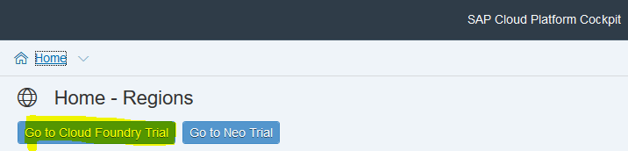
* In the wizard, select a region that is close to you.
* Choose OK.  
  You can view the progress of creating the global account, subaccount, org, and space in your trial account in the wizard.
* Choose Go to Space.

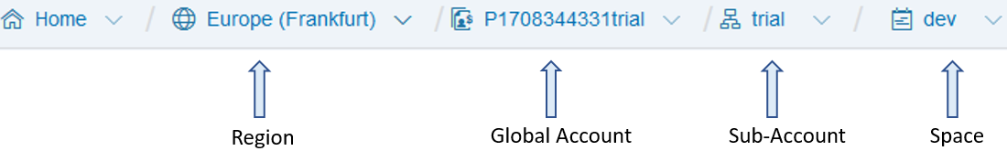This takes you to Home Region (of your choice) Global Account (<user ID>trial) subaccount (trial)🡪Space (dev) .

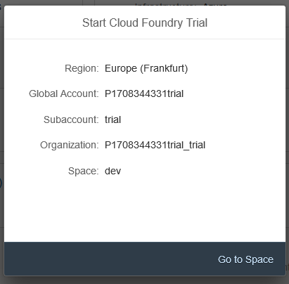

# Installation of CF-CLI:

Cloud Foundry (cf) command line interface (CLI) provides a set of commands for managing your apps.

**How do we install CF-CLI???**

**1.🡪 Perform the following steps:**

* [Download](https://cli.run.pivotal.io/stable?release=windows64&source=github) the Windows installer.
* Unpack the zip file.
* Double click the cf CLI executable.
* When prompted, click Install, then Close.
* To verify your installation, open a terminal window and type cf. If your installation was successful, the cf CLI help listing appears.

**2. 🡪 Alternative Way:**

Install the software using the file and change the extension from .txt to .exe and install cf client.



# Play with CF-CLI

Use the ‘cf’ command line interface (CLI) to log on to the Cloud Foundry space. cf command could be executed through windows command prompt:

Command🡪cf



## Setting CF API End Point:

If your global account is hosted in the Europe (Frankfurt) region, enter the following endpoint:

Command🡪cf api https://api.cf.eu10.hana.ondemand.com

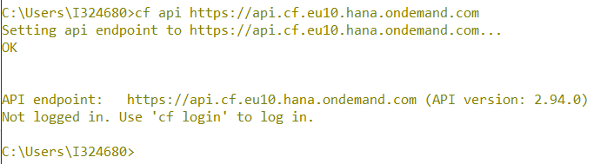

## Log on to CF Instance:

Pass the command,

Command🡪cf login🡪Supply your registered email Address and password

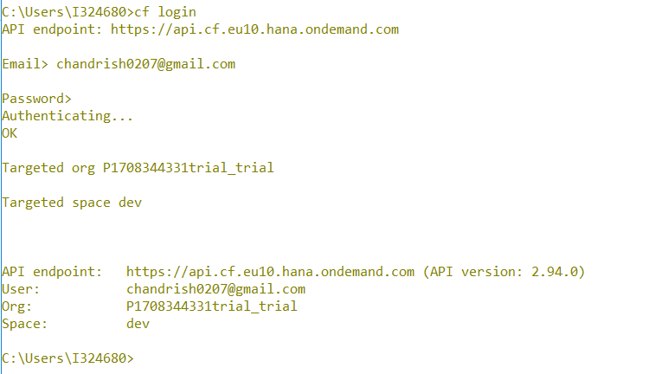

## CF Market Place:

Cloud foundry marketplace is one stop shop to explore all cloud foundry service offering.  
Command🡪cf marketplace

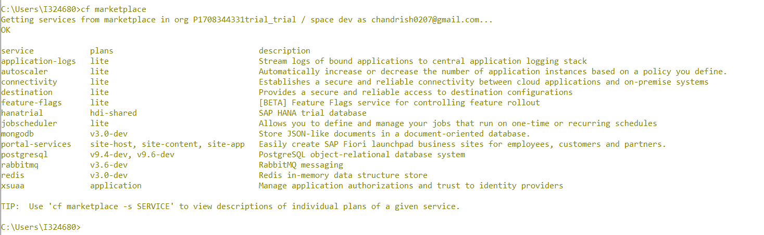

**TIP:** Use 'cf marketplace -s SERVICE' to view descriptions of individual plans of a given service.

## CF ORG:

CF organization will list the details of Domain, Spaces, Quota.

Command🡪cf org <orgname>

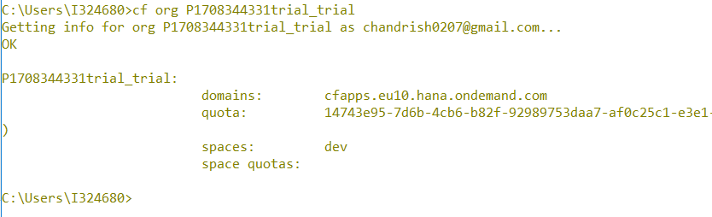

Command🡪cf orgs

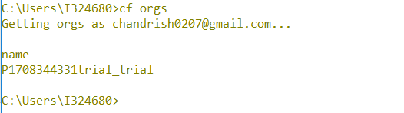

# Creating your first CF Application:

When a Cloud Foundry application resides in a folder on your local machine, you can deploy it and start it by executing the command line interface (CLI) command push.

## Create: JAVA Application using Eclipse IDE

First, you create a dynamic Web project and then you add a simple Hello World servlet to it.

After you have created the Web application, you can test it on the local runtime and then deploy it on the cloud.

**Create a Dynamic Web Project**

* Open your Eclipse IDE for Java EE Developers and switch to the Workbench screen.
* From the Eclipse IDE main menu, choose File🡪New🡪Dynamic Web Project.

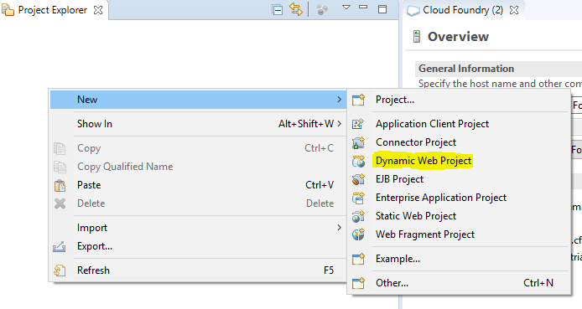

* In the Project name field, enter welcome.
* In the Target Runtime pane, select the runtime you want to use to deploy the java application. In this tutorial, we use Cloud Foundry.
* In the Configuration pane, use the default configuration.

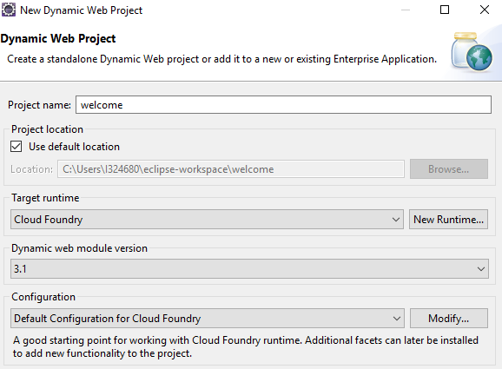

* Optional: If you want your context root to be different from "HelloWorld", proceed as follows:
* Choose the Next button until you reach the Web Module wizard page.
* Edit the Context root field. If you want to deploy the application in the server's root, just replace the current string with "/".

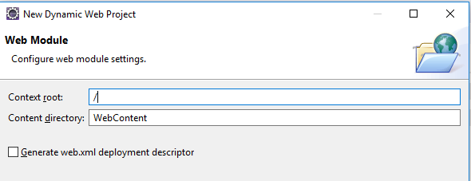

* Click on Finish

**Create a Hello World Servlet**

* On the HelloWorld project node, open the context menu and choose🡪New🡪Servlet. Window Create Servlet opens.

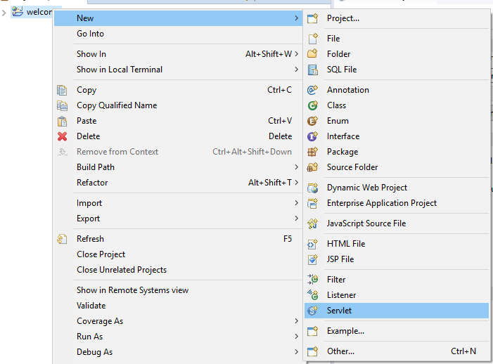

* Enter hello as Java package and welcomemcet as class name.

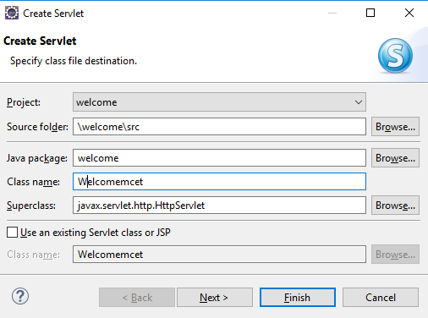

* Choose Next.
* In the URL mappings field, select /Welcomemcet and choose Edit.
* In the Pattern field, replace the current value with just "/". In this way, the servlet will be mapped as a welcome page for the application.  
    
  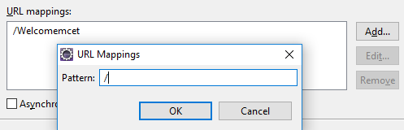
* Choose Finish to generate the servlet. The Java Editor with the Welcomemcet opens.
* Replace the body content of the doGet(…) method with the following line:

response.getWriter().println("welcome MCET Students”);

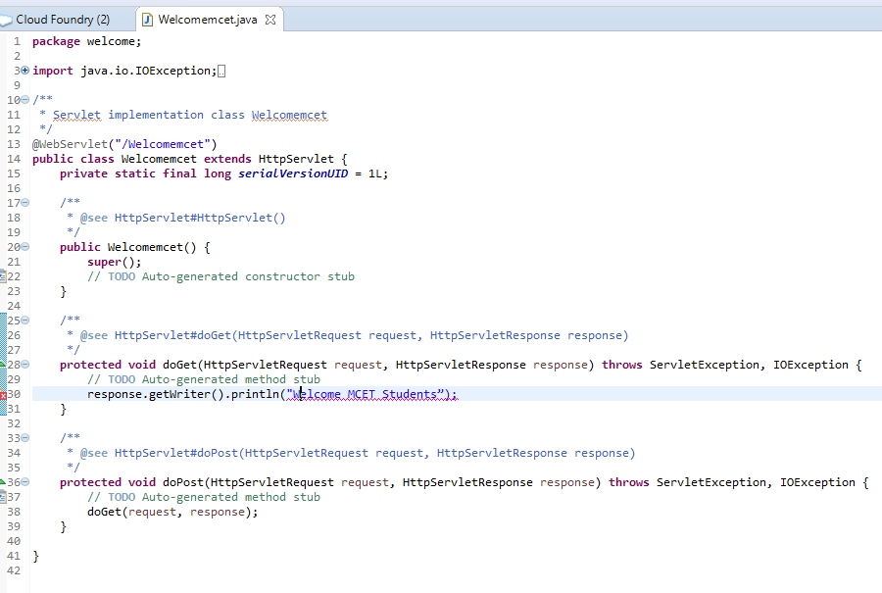

* Save your changes.

# Deploy on the Cloud

Before we deploy, first we need to have Eclipse plugin for CF. Follow the below steps to install the plugin

## Deploy using Eclipse Plugin for CF

* Installing the Eclipse plugin for Cloud Foundry
* Click on Help🡪Eclipse Marketplace  
  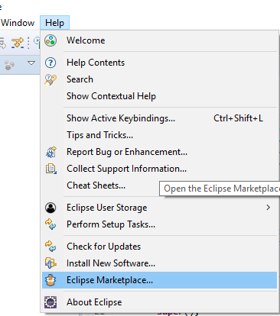
* Search for Cloud Foundry Plugin and Click on install

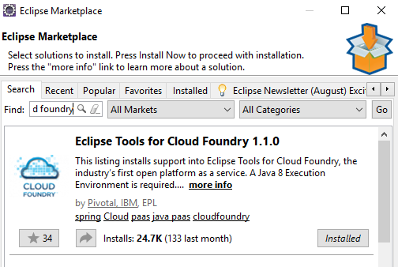

* Navigate to Window -> Preferences -> Server -> Runtime Environments and select Cloud Foundry and choose “Apply and Close”.

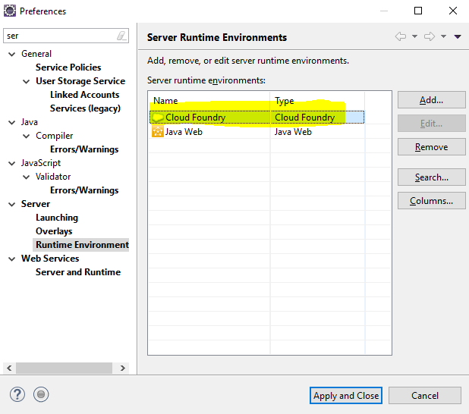

* After selecting the runtime move on to the server view by clicking on Window -> Show View -> Other -> Server.

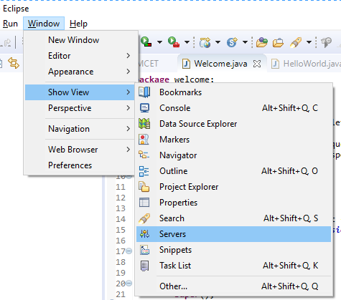

* In the server view, right click New -> Server -> Pivotal -> Cloud Foundry to add the SAP Cloud Platform account to the server view.  
  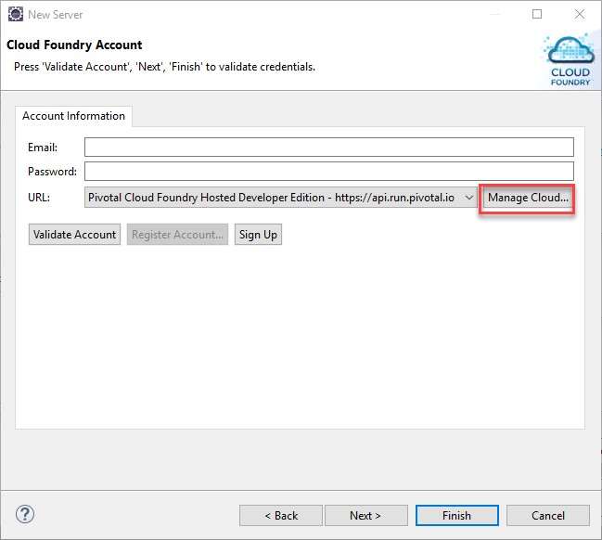
* Select “Manage Cloud URLs” button highlighted above and add the API Endpoint of the Cloud Foundry instance.

API End-Point: <https://api.cf.eu10.hana.ondemand.com> as shown in the below image.

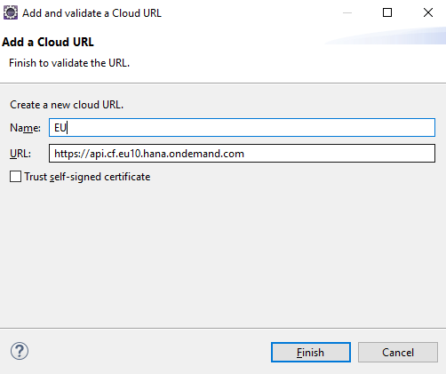

* Select Finish. In the Account Information provide the necessary credentials and click ‘Validate Account’. Upon successful validation, click Finish to add the server account to the server view.
* Double Click on the Server shown in the Servers view to open the Applications Overview Tab. Navigate to Applications and Services to deploy the application.

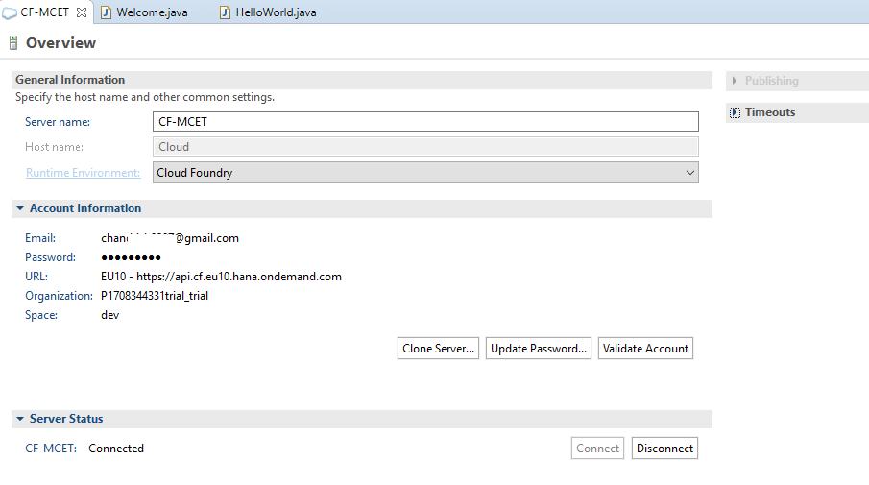

### Deploy the Application on CF Server

Now we are ready with the JAVA application and CF Server, now we deploy the application.

* Right click on the application and select Run as,

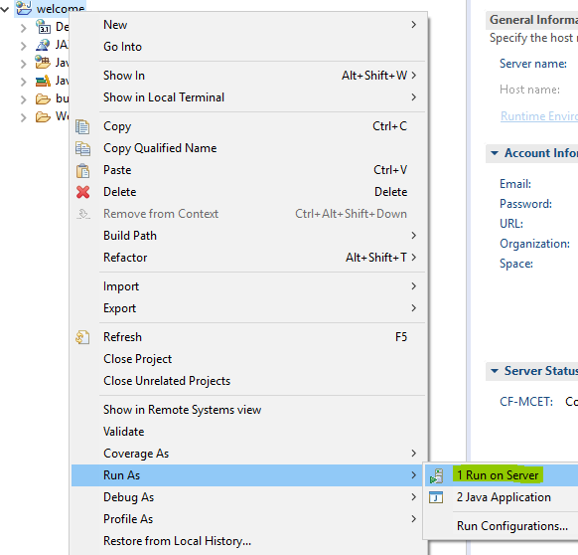

* Checking the status of the application in Console.

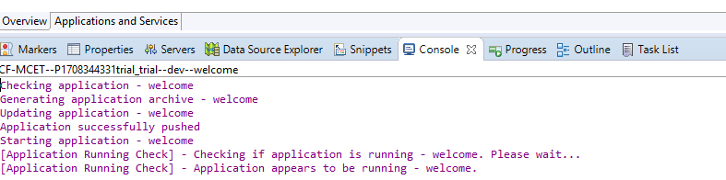

The application can be checked in the SAP Cloud Platform cockpit as well. Login to the cockpit and navigate to the ‘Applications’ section. Click on the application ‘welcome’ to see the details as follows:

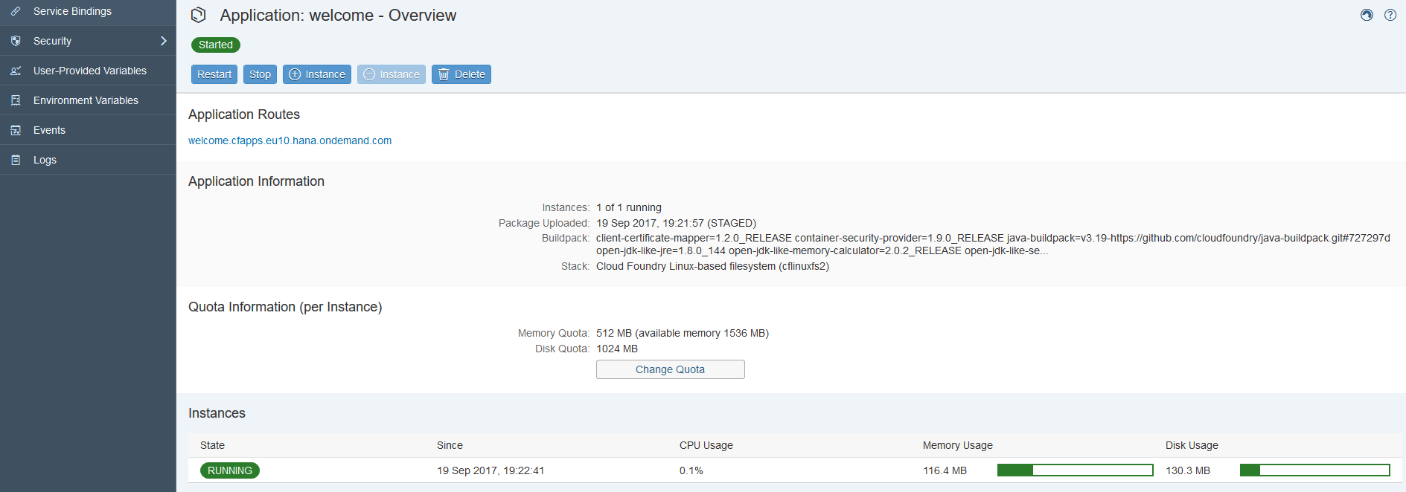

* Clicking on the Application Route link would display the ‘Welcome to MCET Students’ text.

## Deploy using Console Client

* Create an application and save it in your local share or use this file listed below and save it.



* Use the command🡪 cf push [which simply pushes your application in your space].

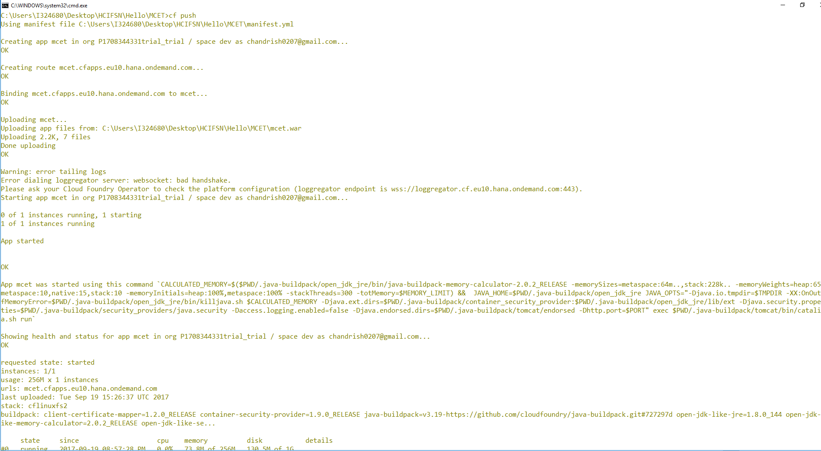

# CICD Pipeline

## GIT Installer

* Download GIT from the following link 🡪 <https://git-scm.com/download/win> or copy from the share and install it using .exe file
* Once installed check the installer using cmd by command 🡪 git -version

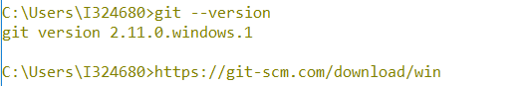

**Introduction about GITLAB & Pipelines- Scenario:**

## Get started with GITLAB

* Create an account in [gitlab](https://gitlab.com/users/sign_in) with filling the necessary details

## Creating New Project

* Login to the gitlab with registered user id and click on ‘+’ and select New Project

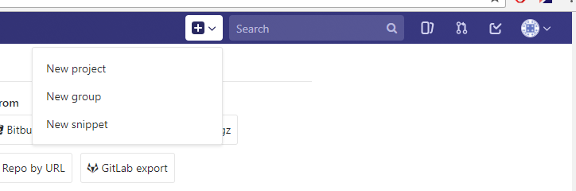

* Give the details of Project Name and a Description about the project.

**Note:** Make sure you select Visibility Level to “Public”.

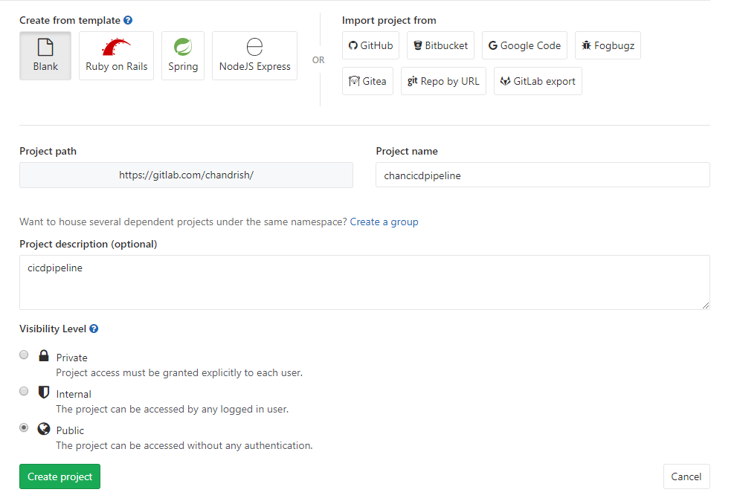

* Configure the GITLAB using from CMD
  + Command 🡪 git config –global user.name “Chandrish”
  + Command 🡪git config –global user.email “example@gmail.com”

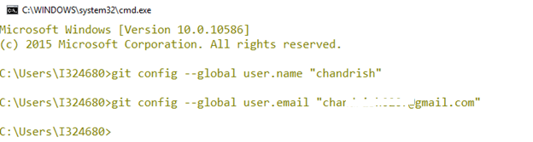

Copy the source code to the location [either from Share or below file] where. git is present (Since it’s a micro service that you are building its necessary its version controlled) and deploy from the PWD.

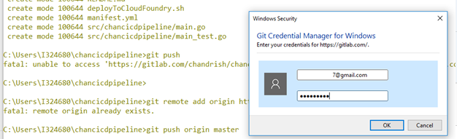

## Setting CI-CD Pipeline Variables:

Goto🡪Setting🡪Secret Variables

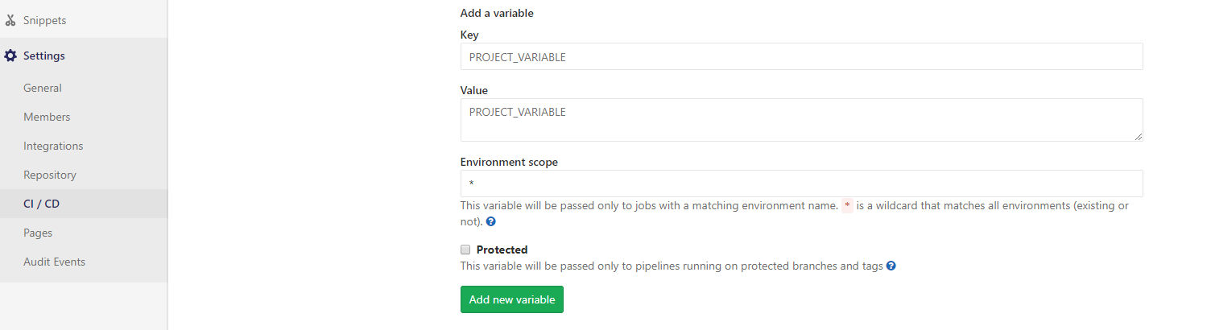

**Supply Details:**

Key =CF_API_ENDPOINT  
VALUE = https://api.cf.eu10.hana.ondemand.com

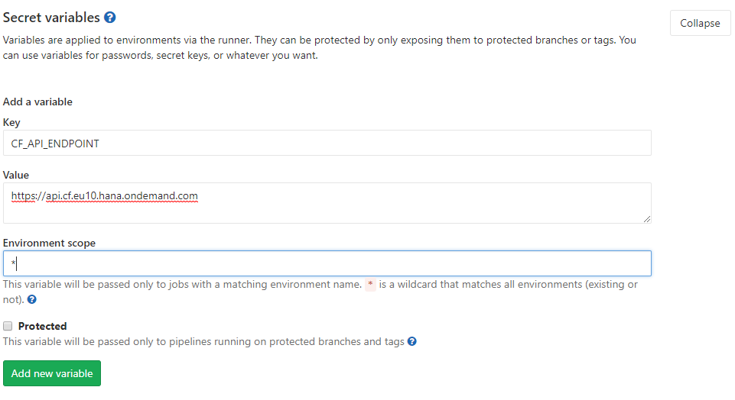

**Supply Details:**

Key =CF_USER  
VALUE = example@gmail.com

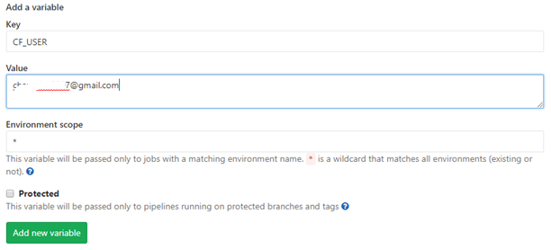

## Versioning Source Code

* The source code needs to be versioned under git.
* Use the command🡪git add . [from the location where .git and source code is present]
* Next command 🡪 git commit -m “This is my first project”
* Next command 🡪 git push origin master

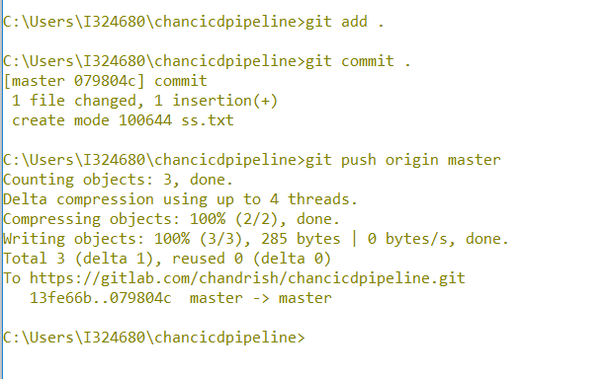

* Next check the status of your commit in the pipleline.

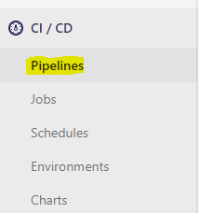

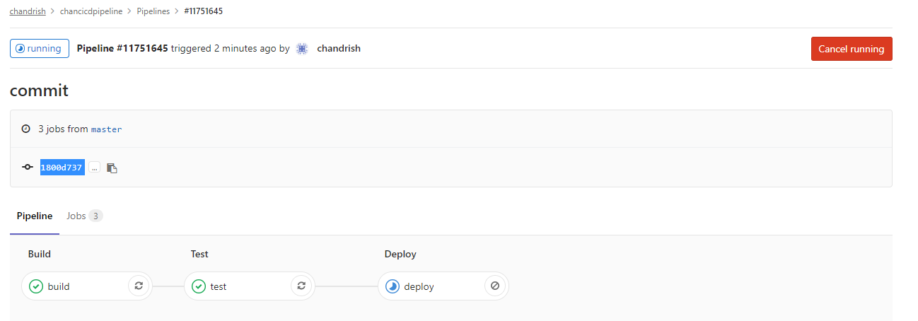

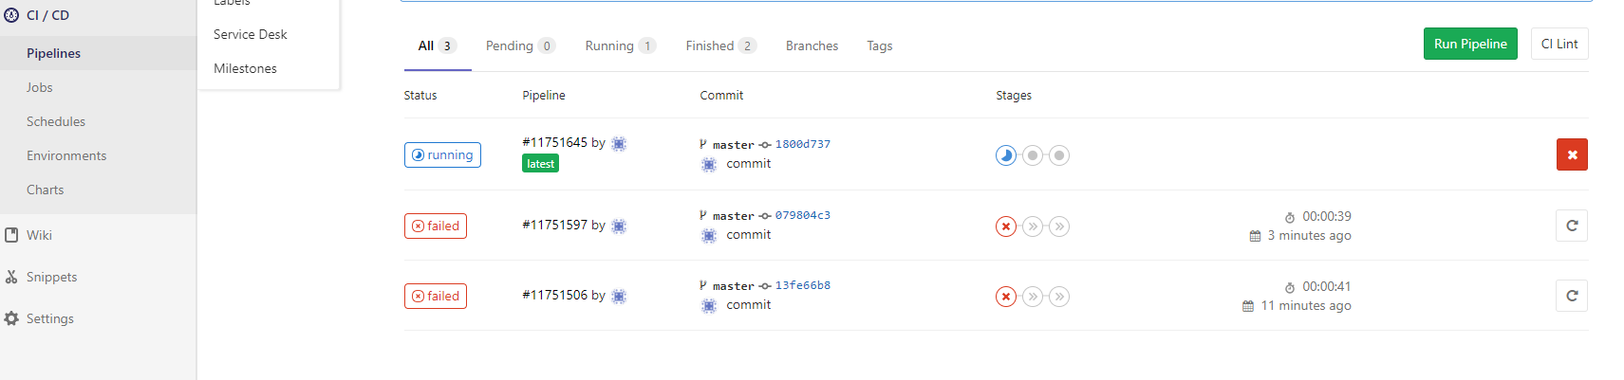

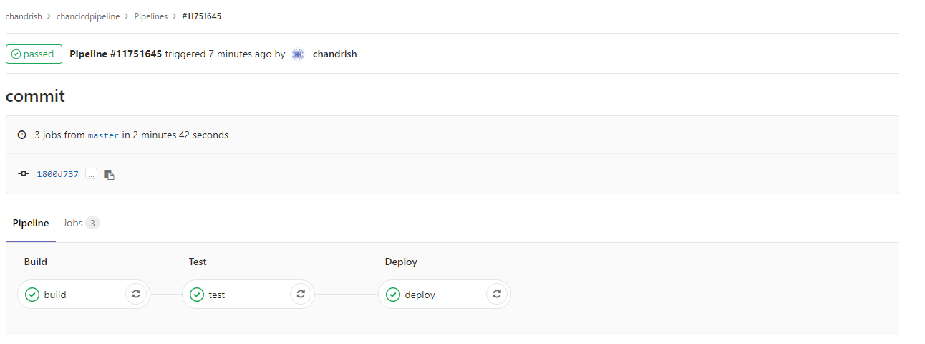

* Parallely check the status of your application deployed through CI-CD Pipeline from CLOUD Cockpit.

